Palestinian Central Bureau of Statistics (PCBS)

A decrease in registered* Exports and Imports in Goods by 6% and 11% respectively in February, 02/2020

Exports in Goods
Exports decreased in February, 2020 by 6% compared to January, 2020. It also decreased by 5% compared to February, 2019 and reached USD 79.5 Million.

Exports to Israel decreased in February, 2020 by 9% compared to January, 2020 and it represented 83% of total exports in February, 2020.

On the other hand, exports to other countries increased by 7% during the same period compared to January, 2020 and reached USD 13.8 Million

Imports in Goods
Imports decreased in February, 2020 by 11% compared to January, 2020. It also decreased by 8% compared to February, 2019 and reached USD 421.2 Million.

Imports from Israel decreased by 12% in February, 2020 compared to January, 2020 and it represented 56% of total imports in February, 2020.

At the same time, imports from other countries decreased by 11% compared to January, 2020.

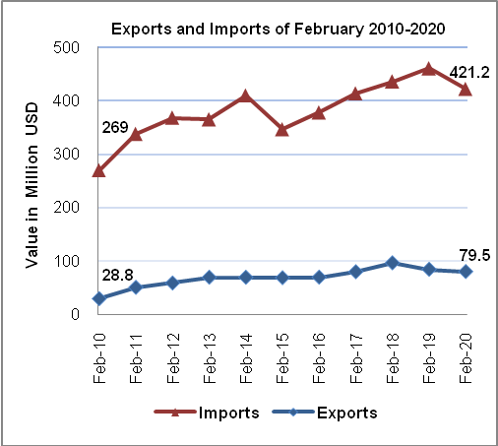
Trade Balance on Registered Goods
The trade balance which represents the difference between exports and imports showed a decrease in trade deficit by 12% in February, 2020 compared to January, 2020. It also decreased by 9% compared to February, 2019 and reached USD 341.7 Million

