**Palestine, represented by Palestinian Central Bureau of Statistics (PCBS)**

**ranks 2nd in Western Asia and the Middle East Region and 17th in open data in the World**

**Ramallah – 15/02/2023 -** Palestine ranks 17th in the Open Data Inventory 2022 with an overall score of 74. The overall score is a combination of data coverage sub score of 72 and data openness subscore of 76.

Open Data Watch has announced the release of the 2022/23 Open Data Inventory (ODIN)- a global index that assesses countries on the openness of official statistics.  Read the complete report here: <https://odin.opendatawatch.com/Report/countryProfileUpdated/PSE?year=2022>

[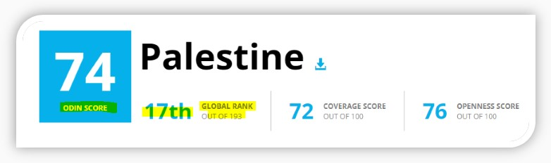](https://odin.opendatawatch.com/ReportCreator/ExportCountryReportUpdated/PSE/2022)

[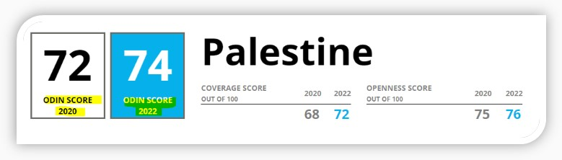](https://odin.opendatawatch.com/Report/multiYearCountryProfileUpdated/PSE?years=2020%2C2022)

[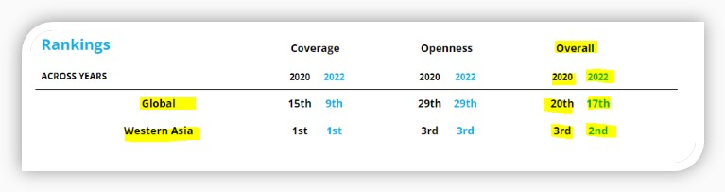](https://odin.opendatawatch.com/Report/multiYearCountryProfileUpdated/PSE?years=2020%2C2022)

[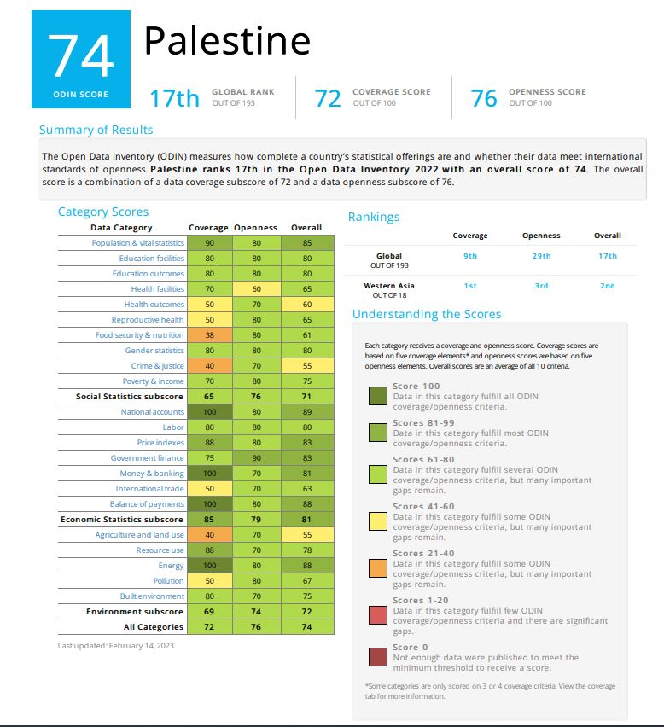](https://odin.opendatawatch.com/ReportCreator/ExportCountryReportUpdated/PSE/2022)