Palestinian Central Bureau of Statistics (PCBS) and the Ministry of Telecom and Information Technology issue a joint press release on the occasion of the World Telecommunication and Information Society Day, 17/05/2023

World Telecommunication and Information Society Day (WTISD) has been annually celebrated on May 17th since 1969 to mark the founding of ITU and the signing of the first International Telegraph Convention in 1865.

The theme of this year's (WTISD) is “Empowering the least developed countries through information and communication technologies.” calling public and private sectors to make pledges for universal connectivity and digital transformation in these countries.

The majority of Palestinian households have access to the internet at their homes
According to Labor force survey 2022, around 92% of households stated that they or one of the household members have access to the internet service at home, (93% in the West Bank and 92% in Gaza Strip).

Moreover, the percentage of individuals (10 years and above) who have used the internet from anywhere reached 89% in Palestine (92% in the West Bank and 83% in Gaza Strip), where it is 89% among males and 88% among females.

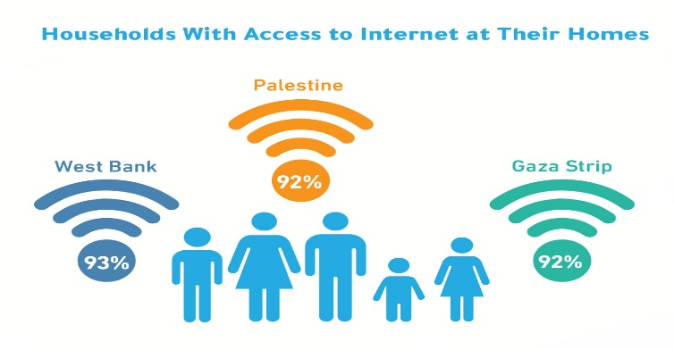

Widespread of smartphones ownership
The percentage of individuals (10 years and above) who own a smartphone is 73% in Palestine during 2022, (83% in the West Bank and 58% in Gaza Strip), where it is 74% among males and 72% among females.

Meanwhile, the percentage of individuals (10 years and above) who own a cellular phone is 79% in Palestine (86% in the West Bank and 69% in Gaza Strip).

Percentage of Individuals (10 Years and Above) Who Own a Smartphone in Palestine by Region and Sex, 2022

Around 4 Million active cellular phone subscriptions
Data from the Ministry of Telecom and Information Technology, 2022, indicated that there was an increase in the active cellular phone subscriptions in Palestine by the end of 2022 reaching around 4.4 million subscribers compared to 2.6 million at the end of 2010, with an increase of 69%.

Meanwhile, there has been an expansion in the fixed network infrastructure, accompanied by increased use by households and institutions of this network and related services, especially the internet service. The number of landlines in Palestine reached 457,706 telephone lines (Home, Commercial, Governmental) at the end of 2022 compared with 360,402 lines at the end of 2010, with an increase of 27%.

Total Number of Fixed and Active Cellular Phone Lines in Palestine for
Selected Years (Thousands)

A decrease is observed in the number of fixed telephone lines in 2022 compared to 2021, due to the launching of the internet service via optical fiber (FTTH), which does not require a fixed telephone line, in contrast to the internet service via the copper network.

More than fifty thousand subscribers to the optical fiber service
The total number of ADSL subscribers in Palestine increased to about 358 thousand subscribers by the end of 2022 compared with 119 thousand subscribers by the end of 2010, with an increase of 201%. The average of internet speed was 26 Mbps at the end of 2022 compared with 13 Mbps at the end of 2021.

The figure below indicates that there is a noticeable decrease in the number of high-speed internet subscribers (not including optical fiber subscribers) when compared with the year 2021. Knowingly, 2022 was the actual year for the spread of the optical fiber network in Palestine, as the number of subscribers to the optical fiber service reached about 51,759 subscribers at the end of 2022, which explains the decrease in the number of high-speed internet subscribers as a result of the subscribers' transition from ADSL service to FTTH service.

Total Number of ADSL Subscribers in Palestine, for Selected Years (Thousands)

Data of the Ministry of Telecom and Information Technology 2022 indicated that there are 9 companies operate as internet providers; 7 of which are companies licensed for broadband services, one company licensed to establish and operate optical fiber networks, and the last one is an internet provider working over Bit-Stream Access (BSA) model. Moreover, there are 103 wireless Wi-Fi networks that have been granted a license to operate. In the same year, licenses were granted to 67 companies to import wired and wireless communication devices, in addition to 15 companies to provide value-added services. In the aforementioned year, MTIT registered 706,617 new mobile devices that were introduced to the State of Palestine.

Around two thirds of economic enterprises used the internet for business services
Results of the ICT Business Survey, 2021 indicated that 41% of the economic enterprises in Palestine used computers (desktop, laptop) to perform daily work (45% in the West Bank and 35% in Gaza Strip).

61% of the total economic enterprises used the Internet or had access to the Internet for business purposes (68% in the West Bank and 48% in Gaza Strip).

While 79% of the economic enterprises in Palestine used any social or professional networks (i.e that have a user profile, an account or a user license depending on the requirements and the type of the tool used); ;77% in the West Bank and 84% in Gaza Strip in 2021.

More than half of economic enterprises used the internet for business services
The percentage of economic enterprises in Palestine that received orders for selling goods or services via the Internet was 53% (56% in the West Bank and 44% in Gaza Strip), while the percentage of economic enterprises in Palestine that received orders for selling goods or services via social or professional networks, reached 50% (53% in the West Bank and 41% in Gaza Strip) during 2021.

Percentage of Economic Enterprises in Palestine that Received Orders for Goods or Services (Sales) by Method, 2021

Data excluded those parts of Jerusalem that were annexed by Israeli occupation in 1967.

