**Palestinian Central Bureau of Statistics (PCBS) and the Ministry of Telecommunication and Digital Economy issue a joint press release on the World Telecommunication and Information Society Day, 17/05/2025.**

**Gaza Fights for a Connection with Life, and Digital Equality is a Right**

This year’s World Telecommunication and Information Society Day is observed under the theme “Gender equality in digital transformation”. As a global call for closing the digital gender gap to unlock the opportunity for all, and promote inclusive, safe participation in the digital space. While the world celebrates the power of technology to build more inclusive societies, the besieged Gaza Strip faces one of the harshest forms of digital isolation. The ongoing Israeli aggression continues to systematically target ICT infrastructure, in an attempt to isolate over two million people from the world.

In Gaza, the digital gap has shifted from a developmental challenge to a struggle for survival. The internet has become a vital lifeline, a tool for communication, a means to save lives, and a platform to tell the truth.

**Sharp Decline in Internet Usage in Gaza Strip: Over One-Third of Individuals are Deprived of Digital Access**

The Labour Force Survey data, which was conducted during November – December 2024 revealed a significant decline in internet usage among the individuals (10 years and above). According to the findings, around 39% of the individuals were unable to access the internet even once during the three months preceding the interview. This means that about 61% reported having used the internet during that period (regardless of the quality, frequency, or duration of use). Results also highlighted a slight gender gap, where internet usage percentages reached 63% among males compared to 59% among females.

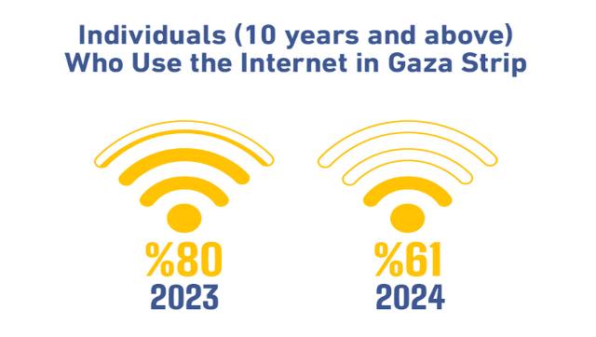

Notably, these figures represent a significant decline compared to the times before the Israeli aggression, where the percentage of individuals who used the internet reached 80%.

**Systematic Destruction of the ICT Infrastructure**

The ongoing Israeli aggression has deliberately and systematically destroyed the infrastructure of the ICT sector, causing far-reaching repercussions across the Palestinian economy and essential services such as healthcare and education. As a cornerstone of innovation and economic growth, the ICT sector has suffered severe setbacks. The damage has not been confined to Gaza Strip; it has also extended to the northern West Bank (particularly in areas such as Jenin, Tulkarm, Tubas, and Nablus) where extensive infrastructure damage has led to significant disruptions and instability in telecommunications and internet connectivity.

In the West Bank, ICT-related businesses, including those in telecommunications, information technology, and postal services, have also come under attack. As a result, the number of licensed establishments registered with the Ministry of Telecommunications and Digital Economy declined by 43% in 2024 a stark indicator of the sector's deterioration amid the conflict.

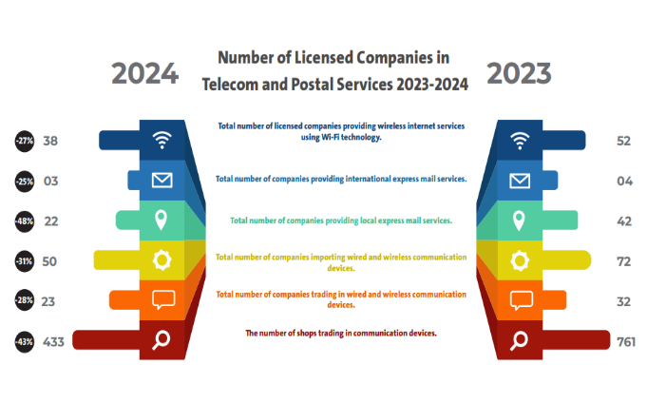

**Around Two-Thirds of Cellular Towers in Gaza Strip are Out of Service**

Prior to the Israeli aggression against Gaza Strip, there were 841 mobile phone towers operated by the Palestinian telecommunications companies. As of the beginning of April 2025, around 64% of these towers were out of service. Moreover, coverage levels vary across the governorates of Gaza Strip, with Dier Al-Balah and Khan Yunis maintaining the highest levels of coverage, while Rafah recorded the lowest, with the coverage dropping to 27%. It is worth mentioning that prior to the Israeli aggression, the total second-generation (2G) network coverage provided by the Palestinian telecommunications companies in Gaza Strip reached 98%.

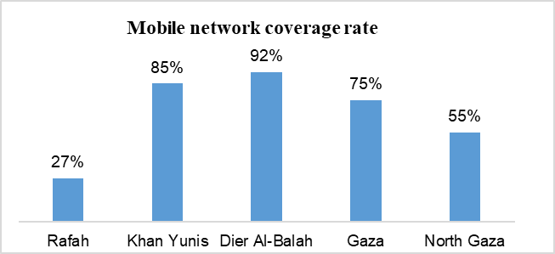

*The data presented correspond to the beginning of April 2025.

Regarding internet and landline penetration in Gaza Strip prior to the Israeli aggression, coverage stood at approximately 93% across the region. As a direct result of the Israeli aggression, coverage in Rafah has been completely lost.

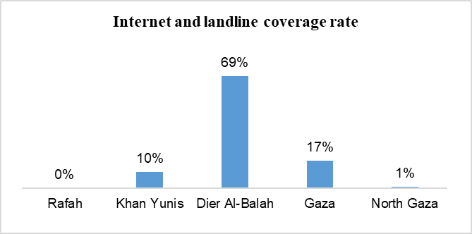

*The data presented correspond to the beginning of April 2025.

**Sharp Decrease in the Value Added of the Information and Communications Activity in Gaza Strip**

The quarterly national accounts estimates for 2024, issued by PCBS, revealed an unprecedented sharp decrease in the information and communications activity, particularly in Gaza Strip, which recorded a decline by 89% in the value added at constant prices.

While the value added of this activity for Palestine reached to around USD 372 million in 2024, compared to about USD 445 million in 2023 (a decrease of around 16%), the West Bank was responsible for the largest share of value added, amounting to nearly USD 371 million in 2024, compared to USD 431 million in the previous year (a decline of 14%).

In contrast, Gaza Strip witnessed a sharp decrease, with the value added dropping from USD 13 million in 2023 to around USD 1.5 million in 2024, reflecting a contraction of 89%. This is a highly alarming indicator of the complete paralysis that has affected one of the most vital activities within the knowledge economy in Gaza Strip, resulted from the direct targeting of the telecommunications and information infrastructure during the ongoing Israeli aggression.

This decrease does not only reflect the scale of economic damage but also the loss of the foundations for digital development and the deepening of the digital gap between Gaza Strip and the rest of the world.

|  |
| --- |
|  |